**DCCM物流管理SO业务操作测试说明V1.0**

**2017-12-07**

## SO销售出货(柜/ISOTANK)

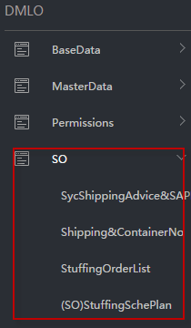

### 数据同步Syc ShippingAdvice&SAPDO

关联ShippingAdvice、SAP Delivery Order

#### 2.1 Create a New Form

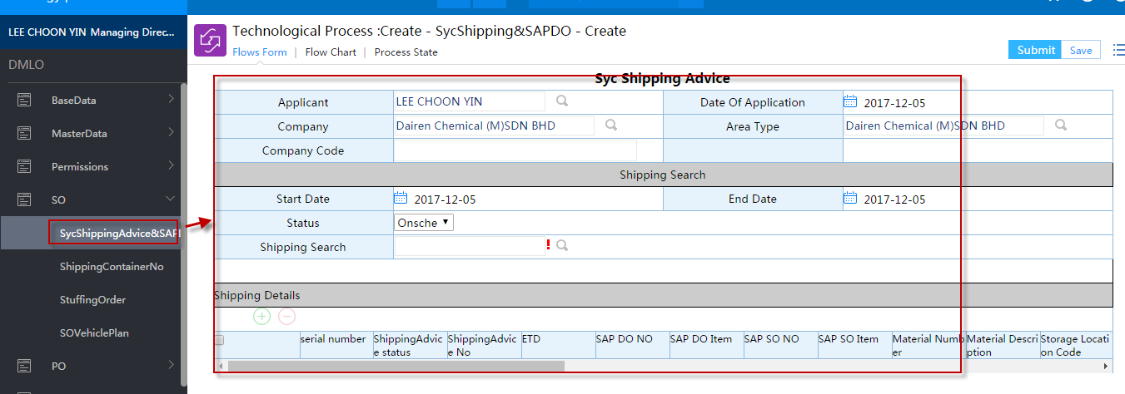

#### 2.2 Select ShippingAdvice

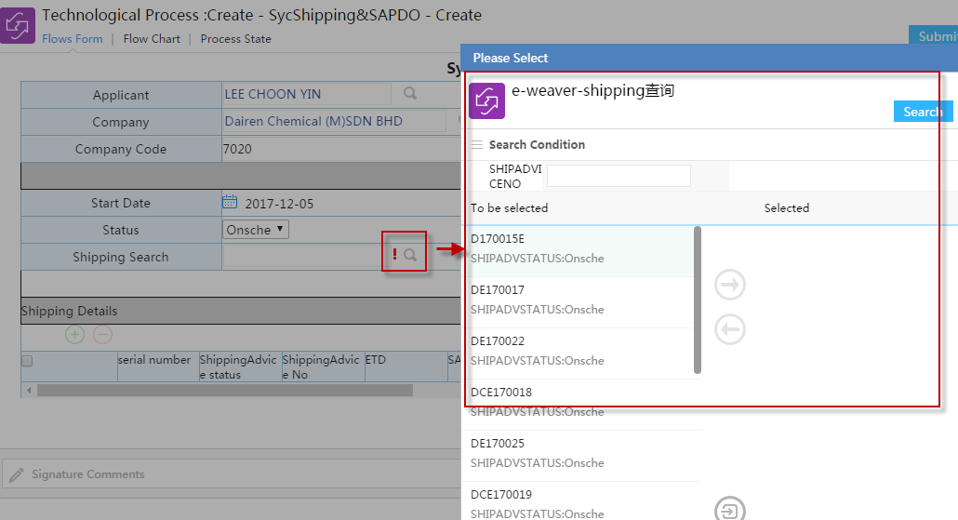

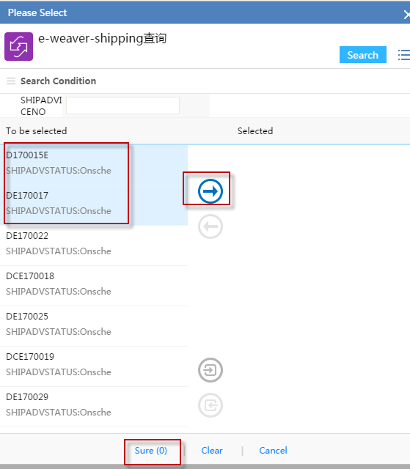

Submit

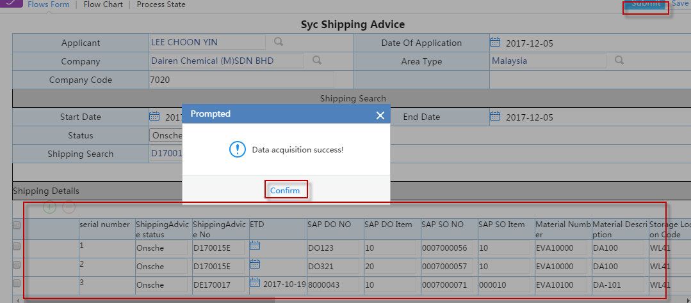

#### 2.3 check Download ShippingAdvice&SAPDO Info

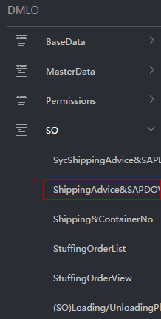

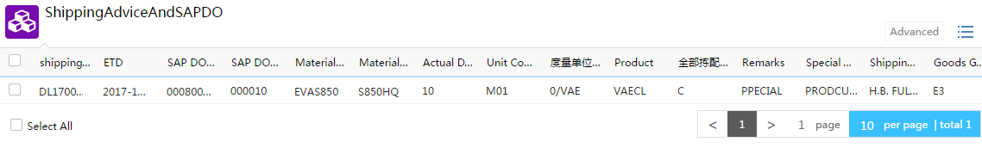

Search Contion

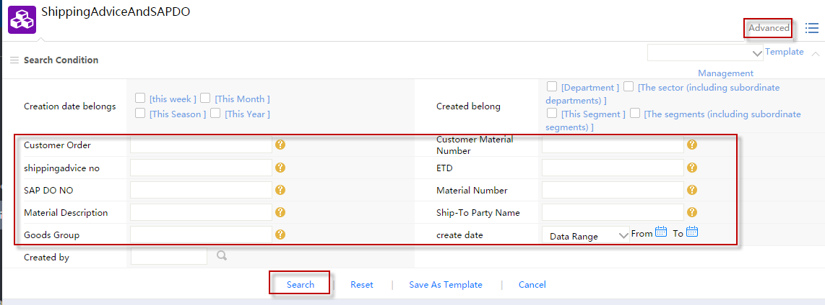

### 柜号录入Shipping&ContainerNo

Shipping柜号或ISOTANK号对应，文件组录入

#### Menu

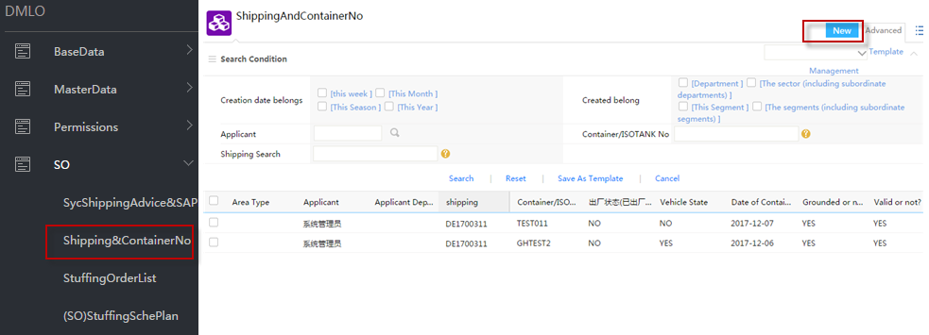

#### New

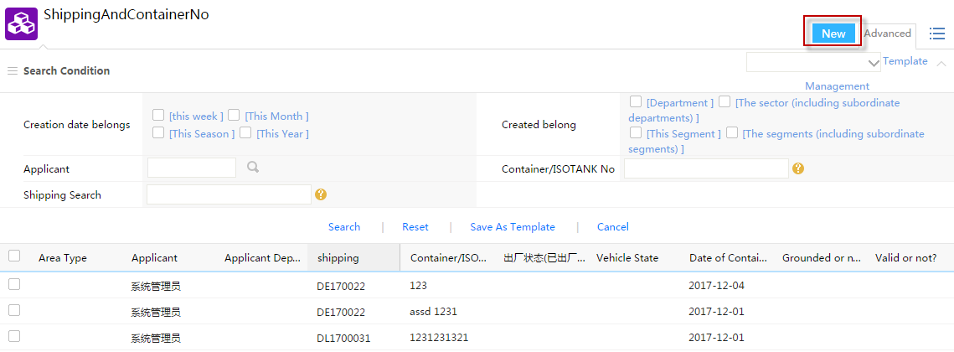

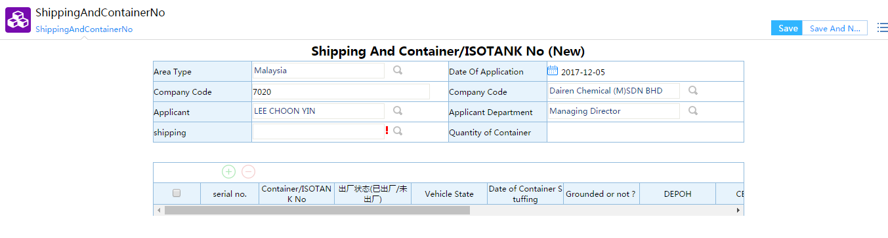

#### Select Shipping Advice No

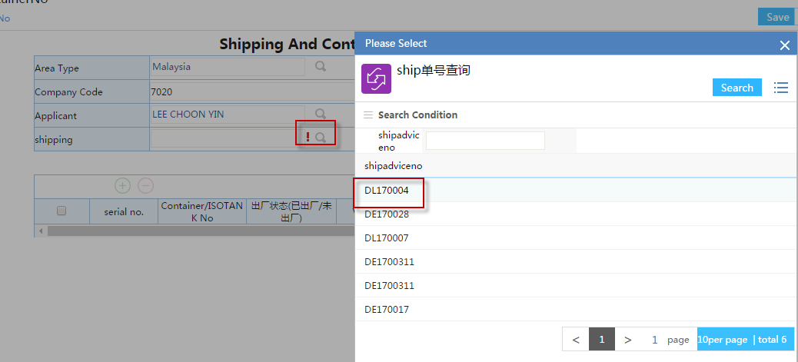

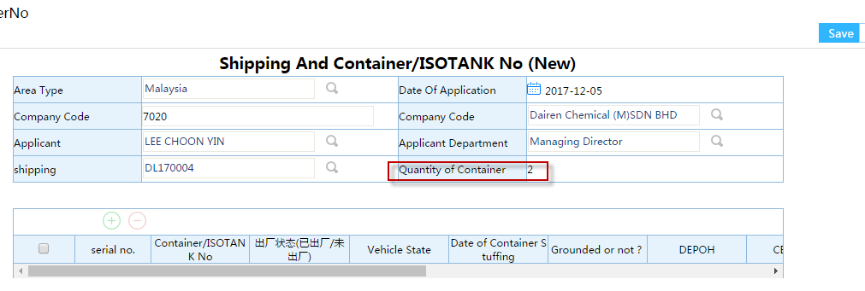

#### Input Details of Container or ISOTANK

Container/ISOTANK No、Date of Container Stuffing、Grounded or not?、Depot Supplier、CBM(M3)、

Remark etc.

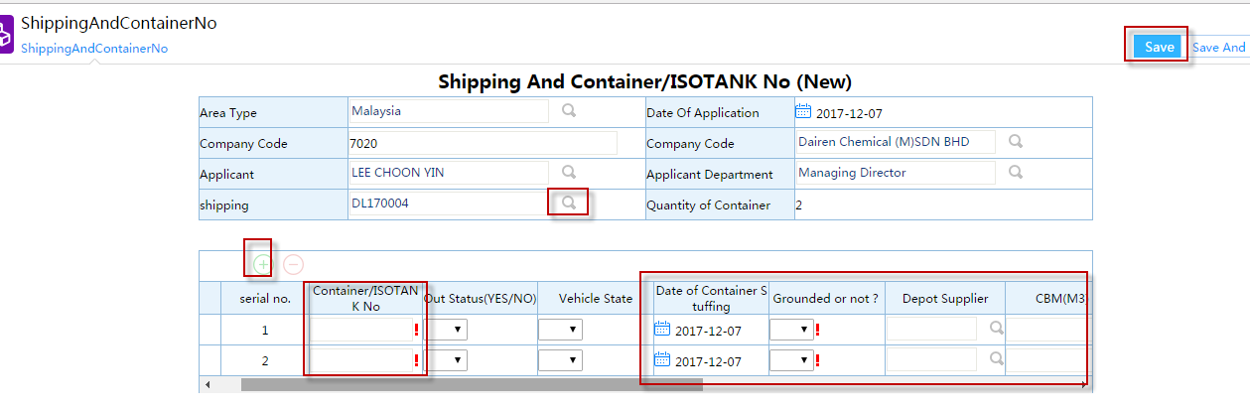

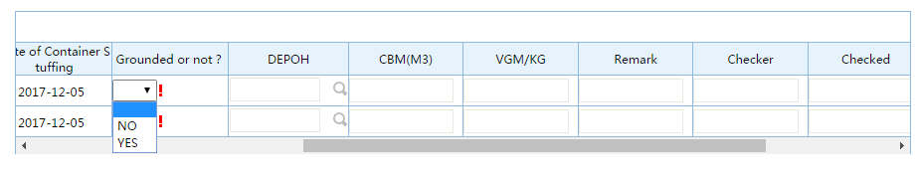

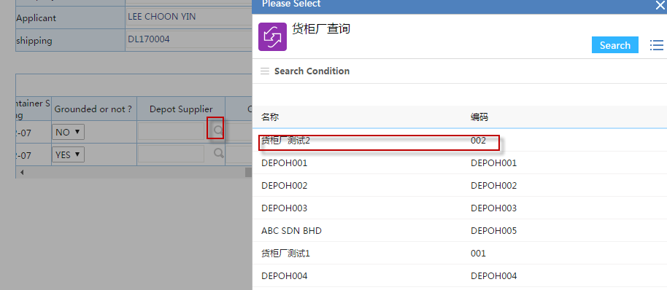

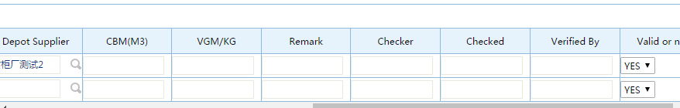

#### Save

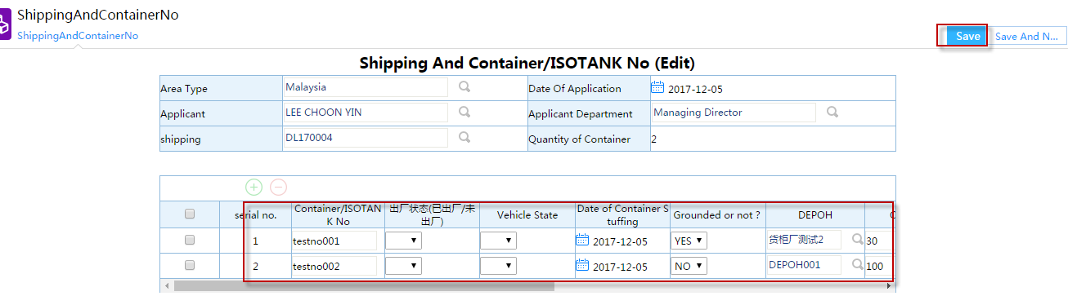

#### Edit

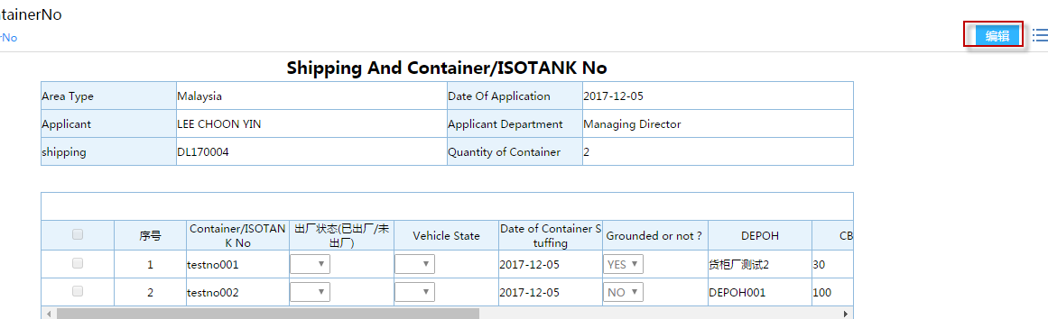

### 理货清单StuffingOrderList

#### Menu

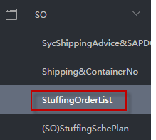

#### Create a New Stuffing Order List

select “Yes or No With Container”

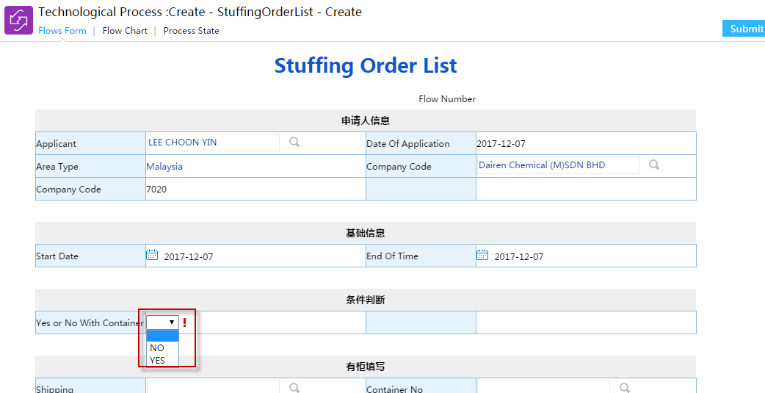

#### With Container/ISO TANK

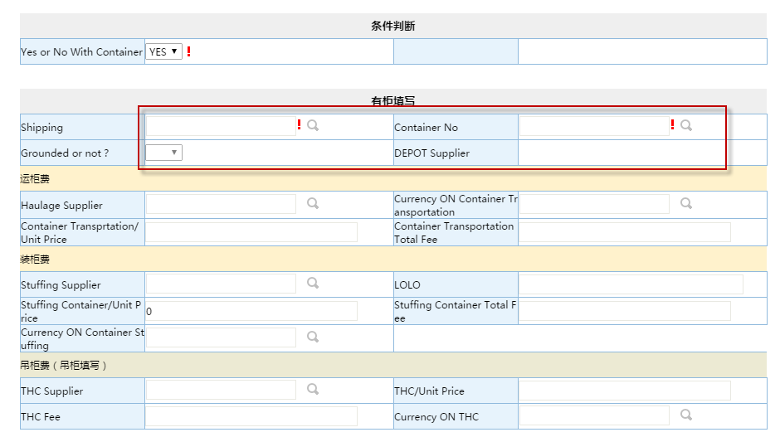

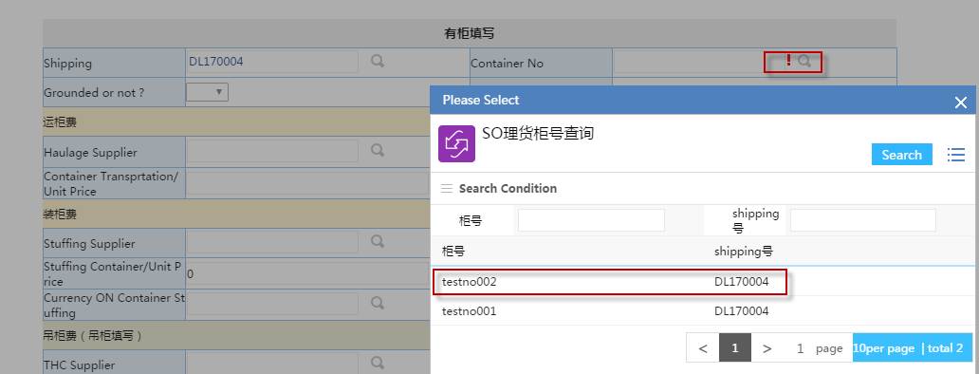

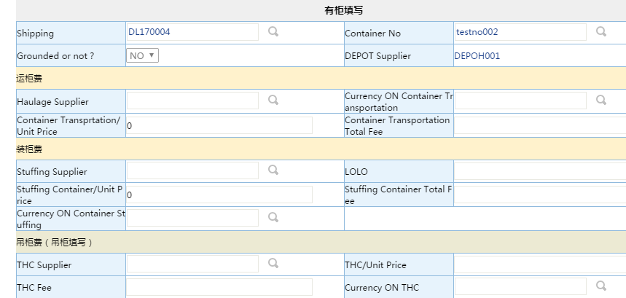

For example: MasterData\LOPrice\Container Price

|  |  |  |  |  |  |  |  |
| --- | --- | --- | --- | --- | --- | --- | --- |
| **Fee Name** | **Supplier Name** | **Supplier Code** | **Depot Supplier** | **LOLO** | **Unit Price** | **Currency** | **Status(Active/InActive)** |
| Container Transportation Fee | COGNIS OLEOCHEMICALS(M) SDN BHD | COG001 | ABC SDN BHD |  | 150.00 | MYR | Active |
| Stuffing Container Fee | B & T HOLIDAY TOURS SDN BHD | DCM043 | ABC SDN BHD | LOLO1 | 120.00 | MYR | Active |
| THC Fee | TATA Grounded SDN BHD | DCM044 |  |  | 50.00 | MYR | Active |

#### Add Stuffing Details, select “SAP DO NO” and “Item”, input “Batch No” and “Current UN Loading Quantities”, then click Submit button

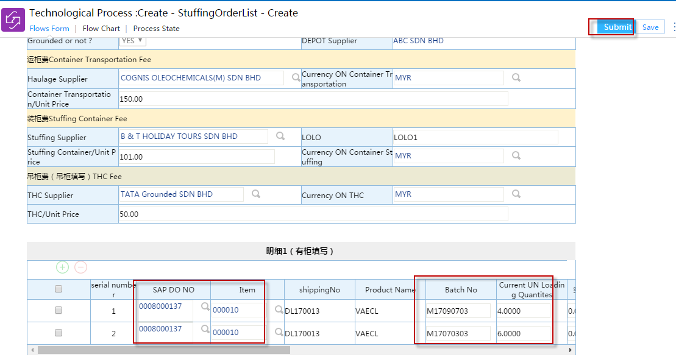

#### StuffingOrderView

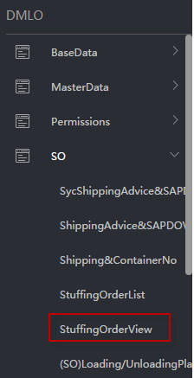

Select Conditions， right click, click “Search”

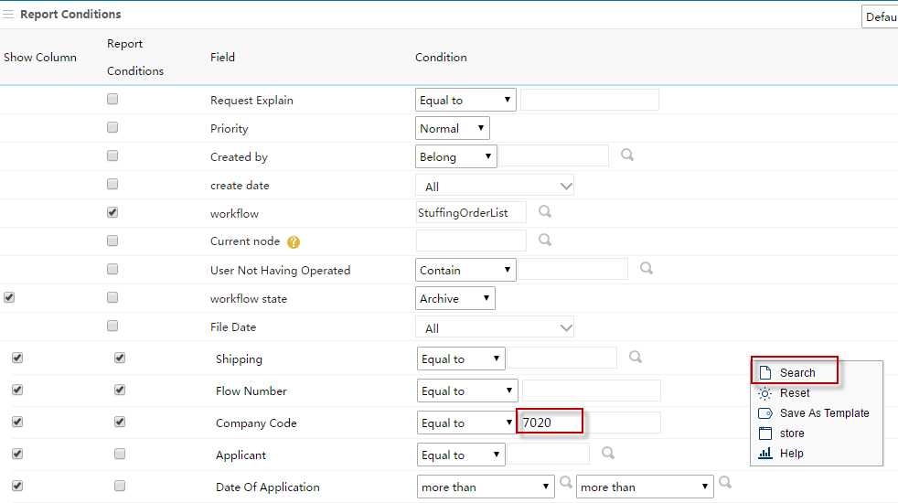

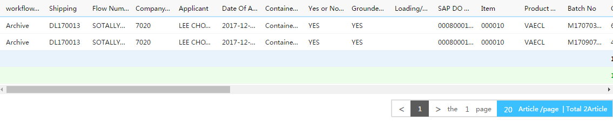

### SO装卸计划Loading/UnloadingPlan

#### Menu

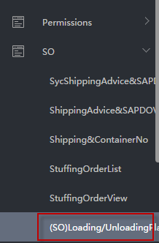

#### Create a New SO Loading/Unloading Plan

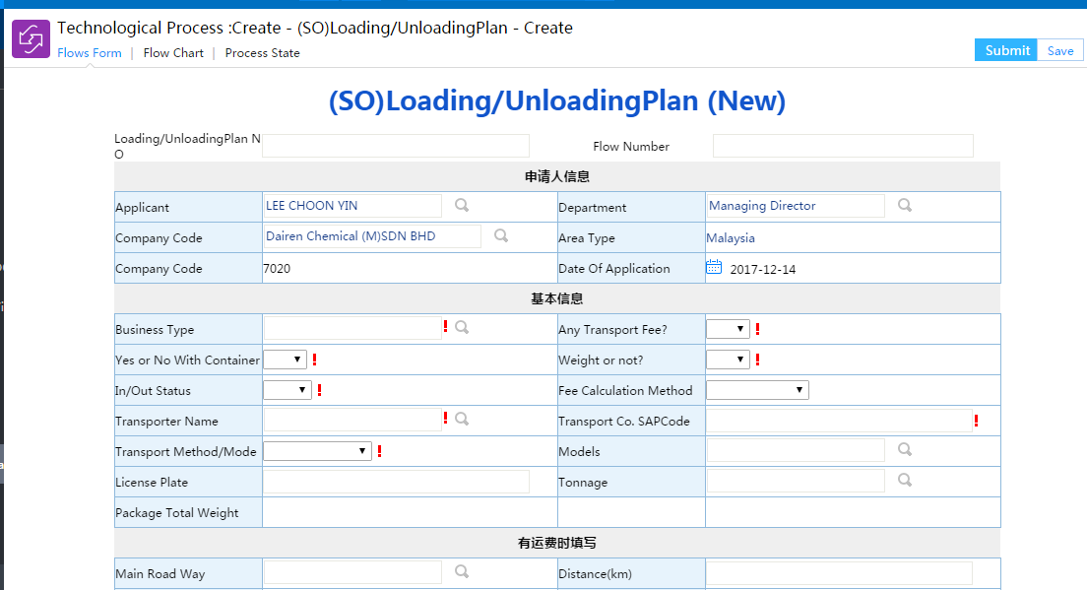

##### Select Basic Information

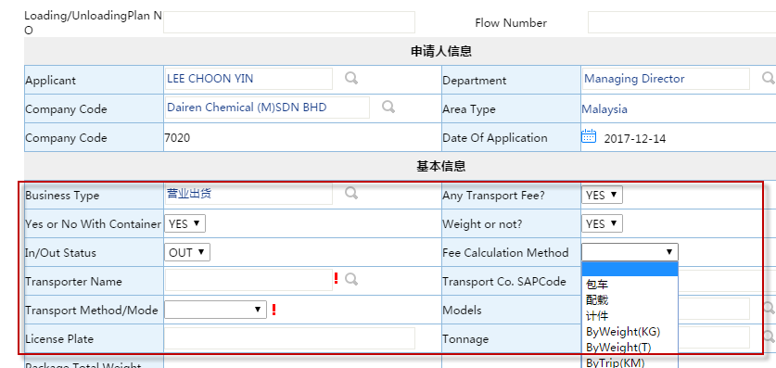

##### Select ”Transport Name”

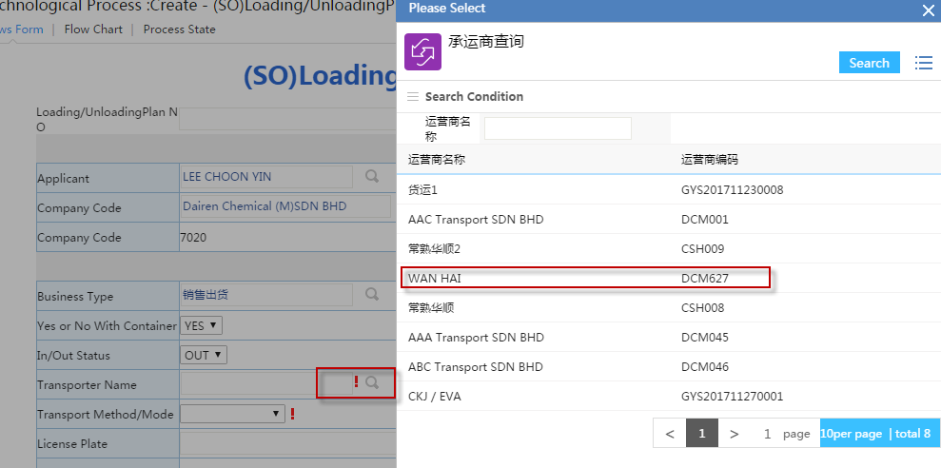

##### Notice: “Transport Name” is from MastrtData\Logisitics Supplier\SupplierMaintain List

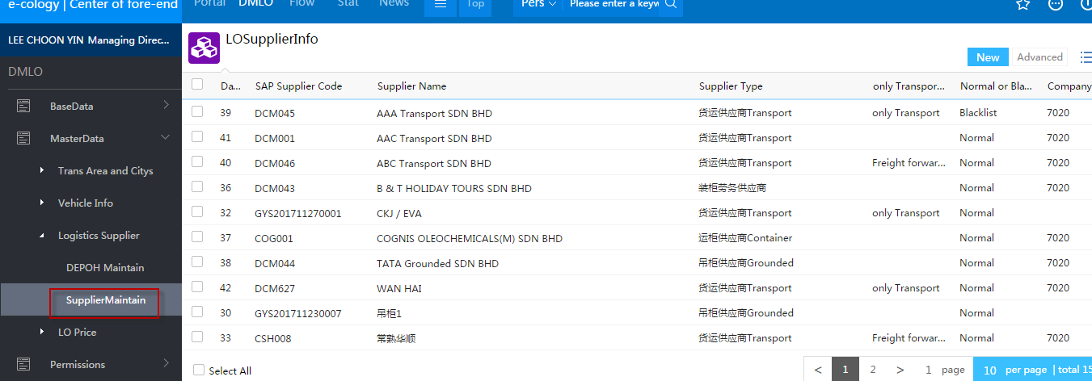

##### Finish “Basic Information” selection

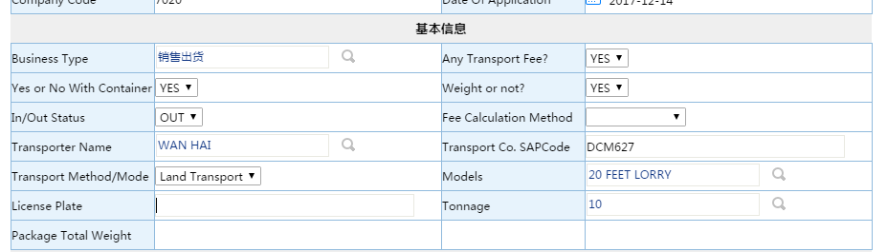

##### If “Any Tansport Fee?” = YES, please input information of Transport Fee

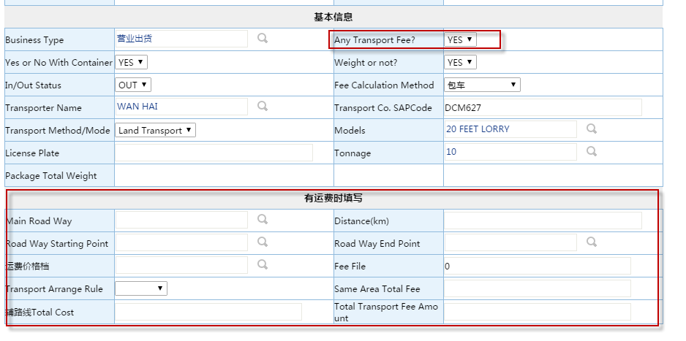

Select “Main Road Way”

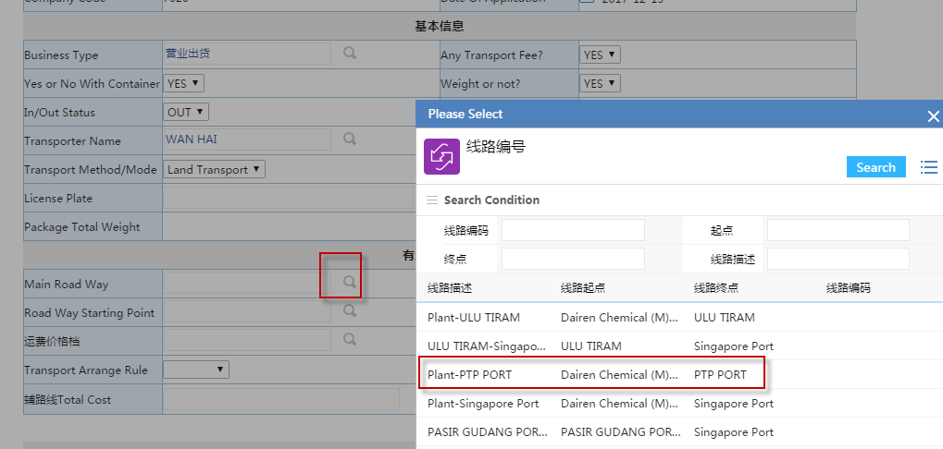

##### Select “The Price file of Main Road Way”, if there is no price, please maintain MasterData\TransportPrice first.

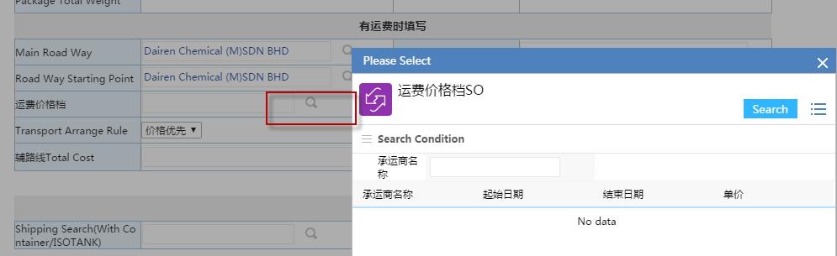

##### How to maintain “The Price file of Main Road Way”

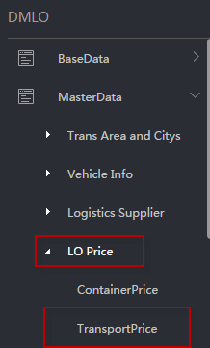

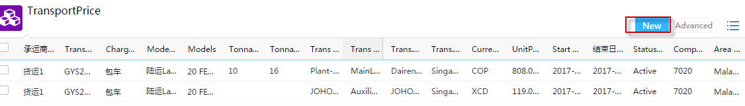

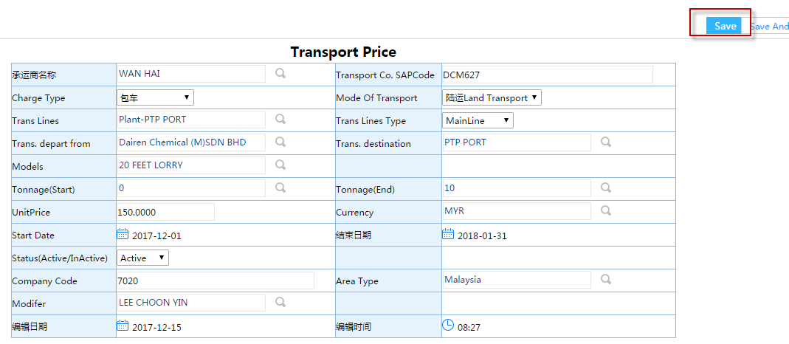

##### If there is price file which matches the information of Transport Fee, you can select one.

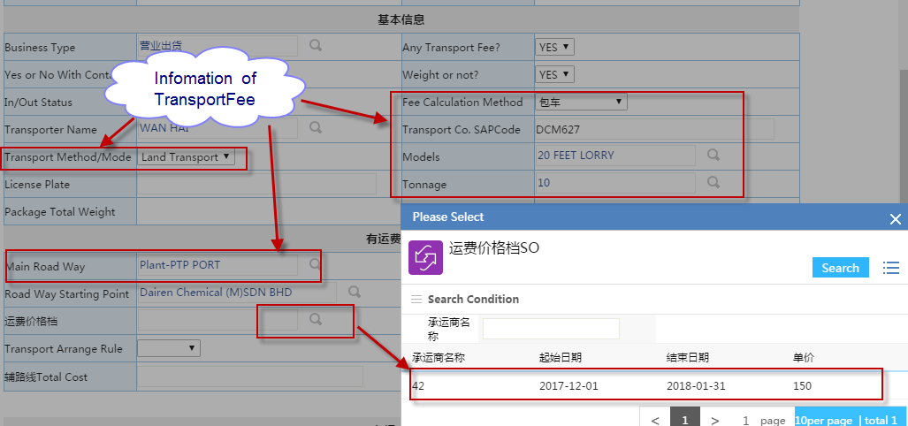

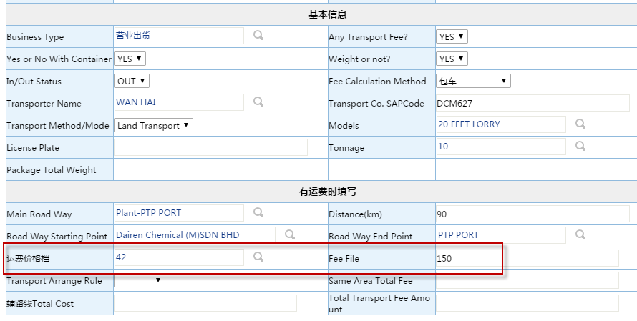

If “Yes or No With Container?”= YES, please select “Shipping Search(With Container/ISOTANK)”and “Container Number Search”

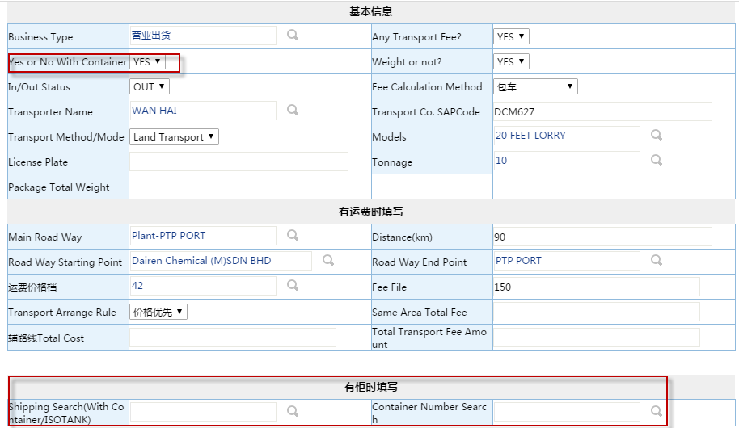

##### Select Shipping

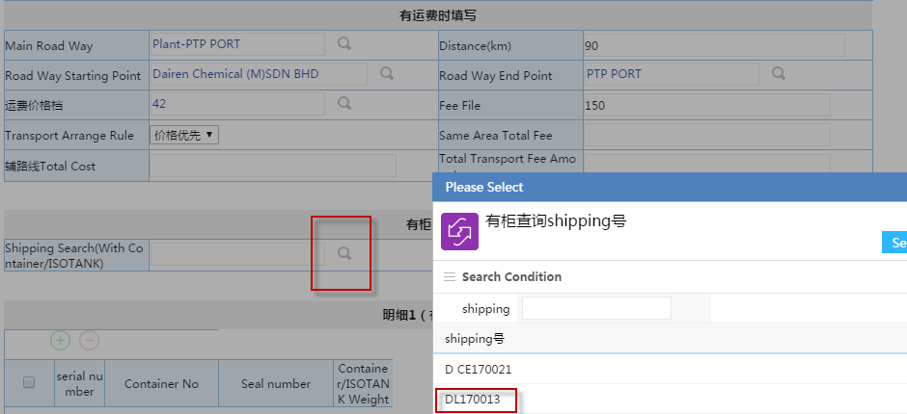

##### Select ContainerNo/ISOTANK No

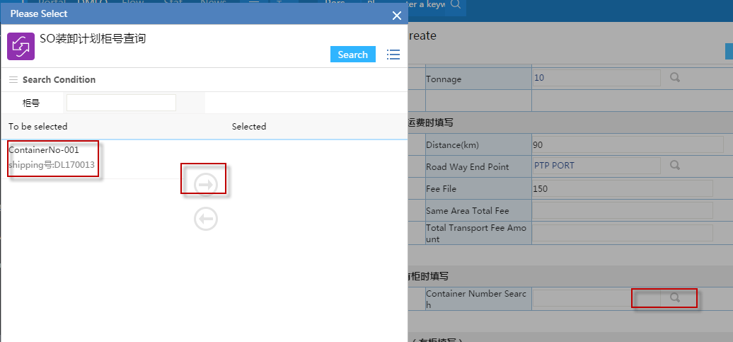

##### Input “Seal number”

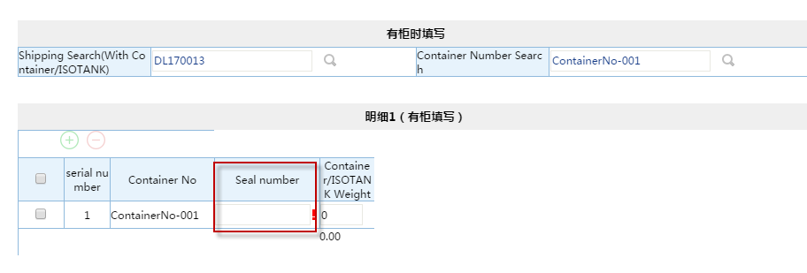

Check the product details of Stuffing Order List

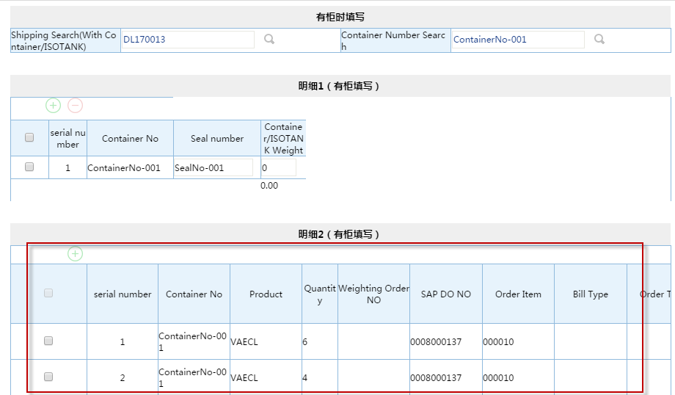

##### Select “City”, and click “生成辅线路”， check the order of City and Fee

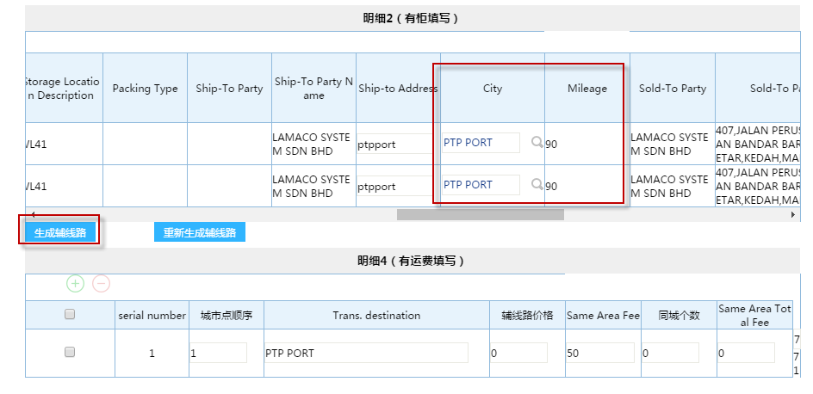

##### Submit

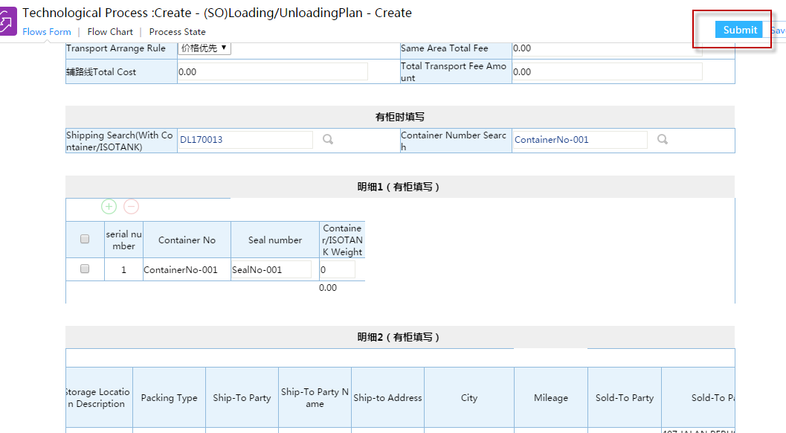

If the Shipping Advice and container exists seal number already, it will provide error message

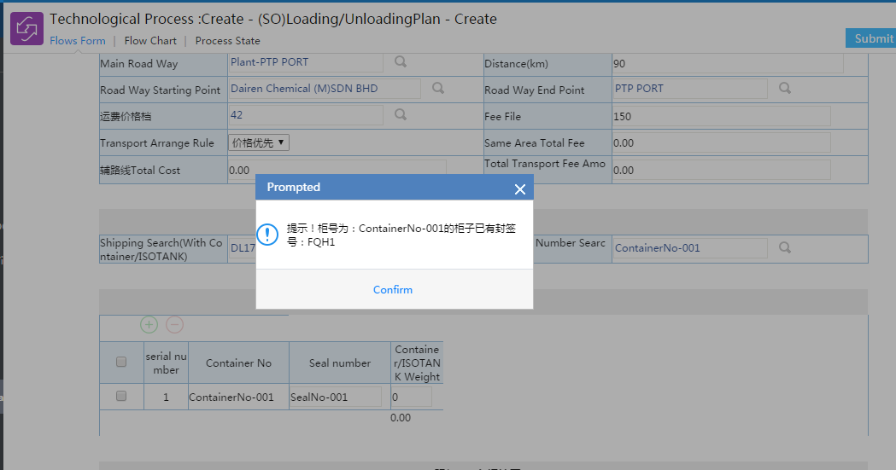

#### (SO)LoadingPlanView

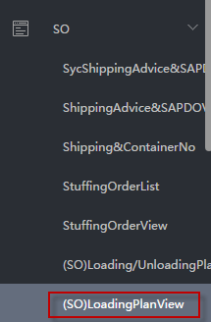

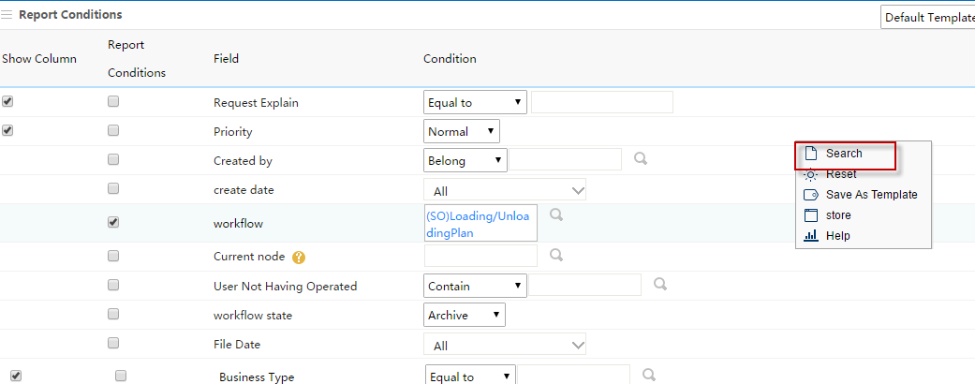

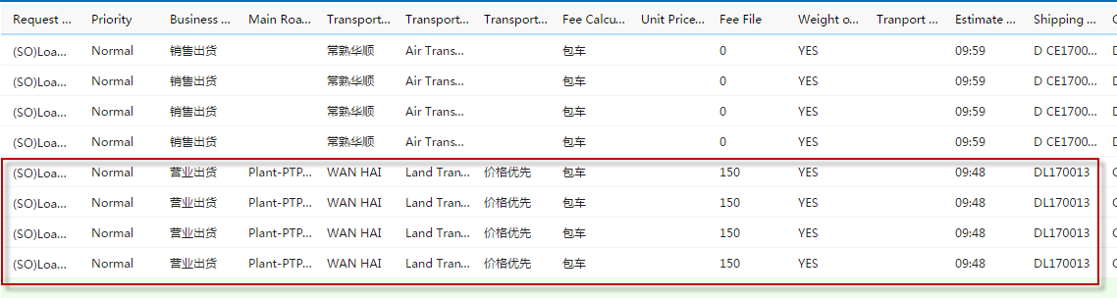

##### Open SO Loading/Unloading Plan Form



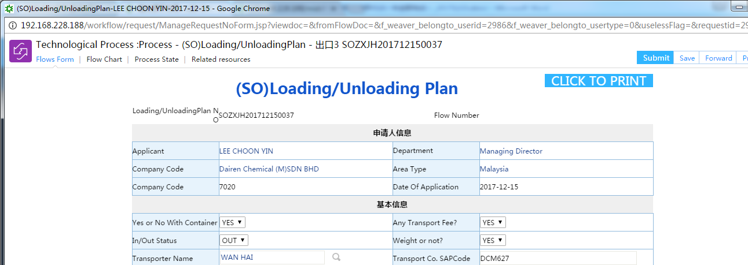

The flow chart of SO Loading/Unloading Plan

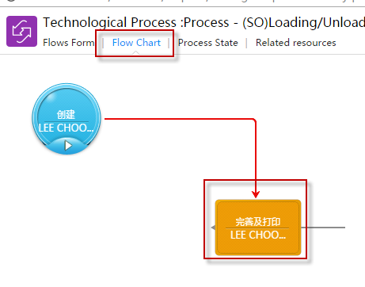

### 5.Print Weighting Order

#### Find Weighting Order NO from Loading/Unloading Plan

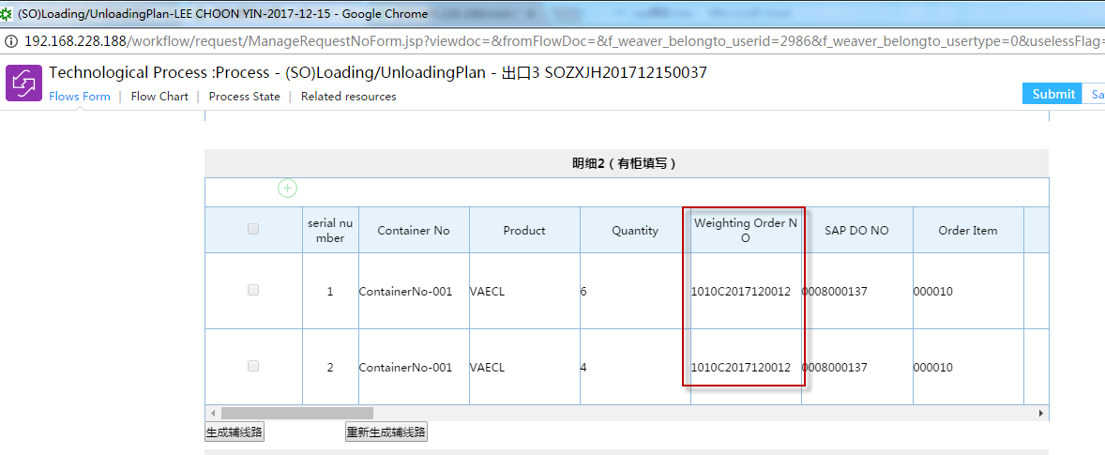

#### Weighting Order View

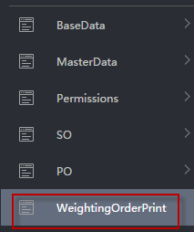

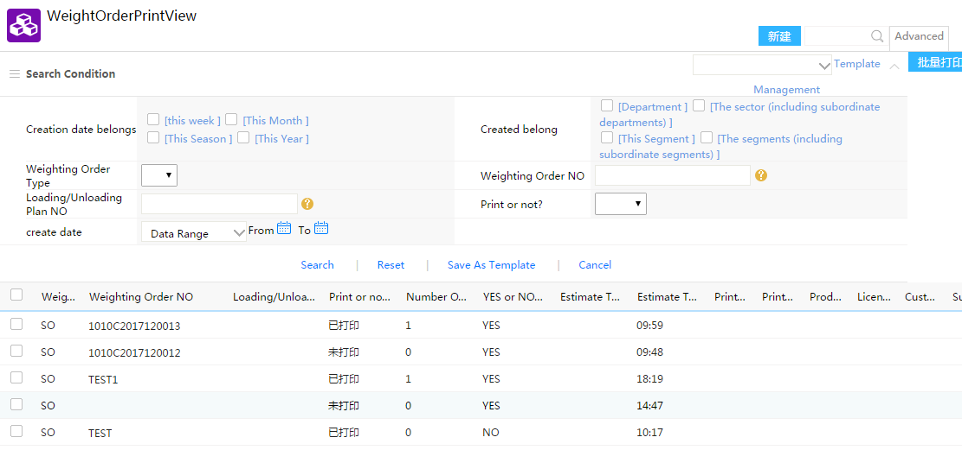

#### Select Weighting Order which you want to print

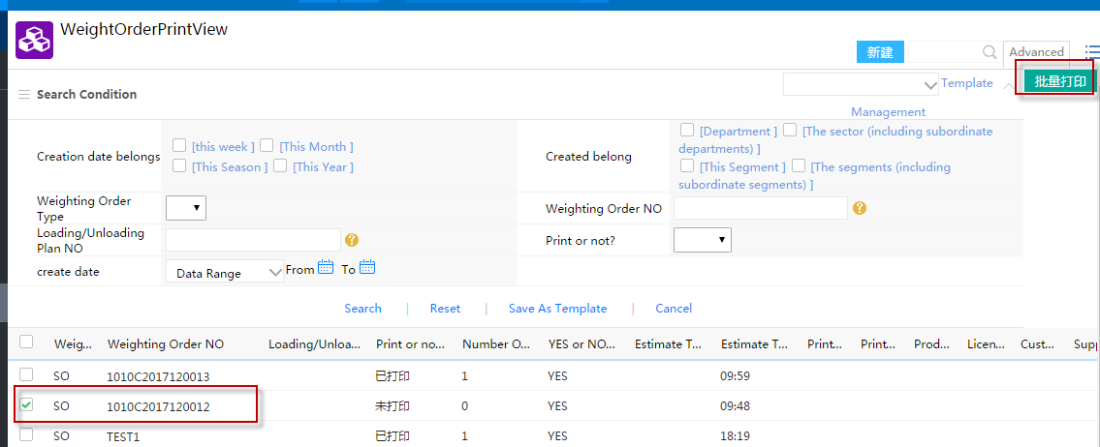

#### If “Print or not?”=NO, allow to print

#### Please set IE/chrome allow website IP

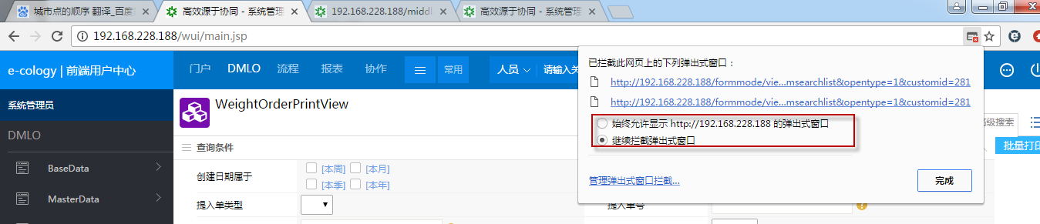

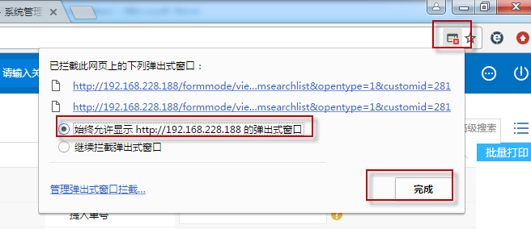

#### Print View and print

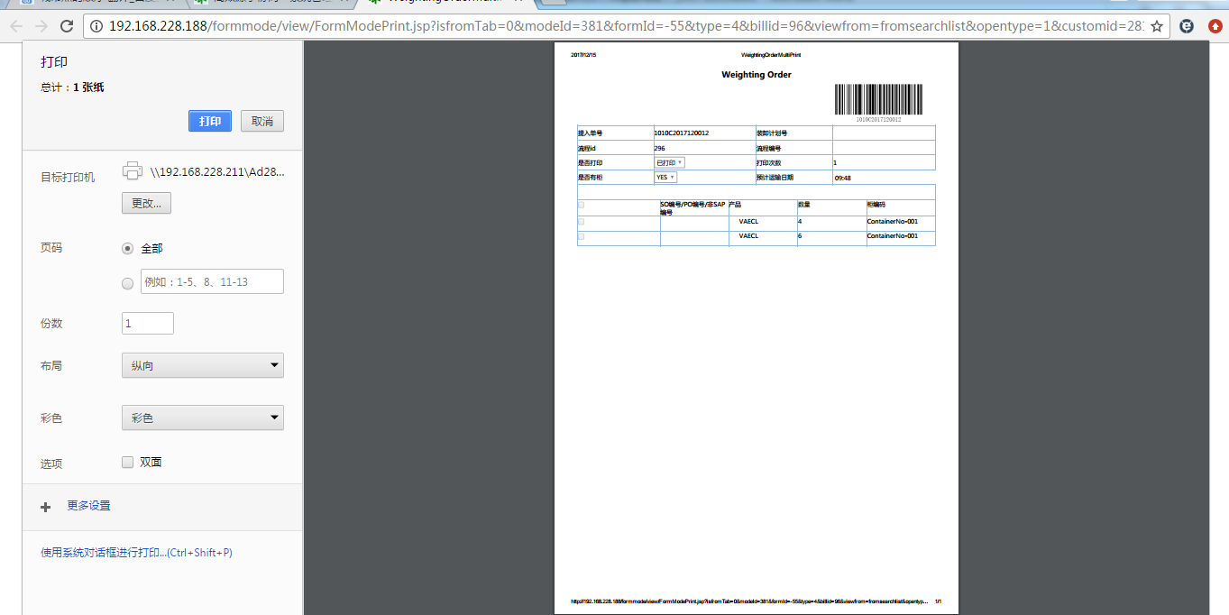

#### After finish print, “Print or not?”=YES and “Number Of print” >0

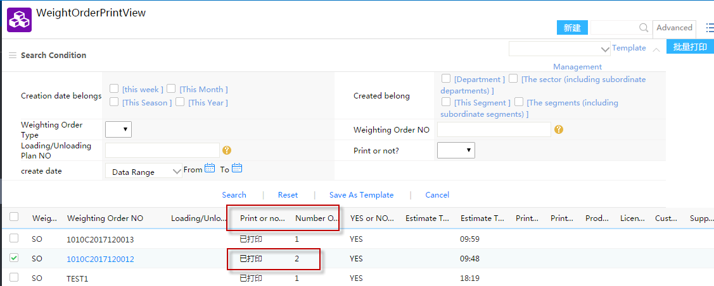

#### If “Print or not?”=YES, you can’t print it again.

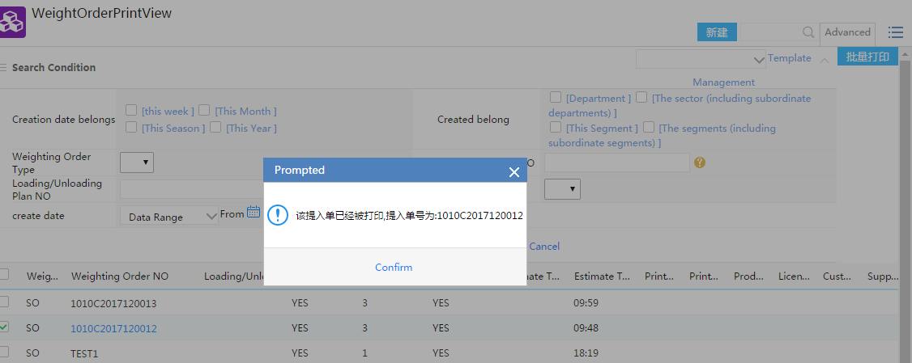

#### Open Weighting Order, change “Print or not?”=NO, and then you can print it again.

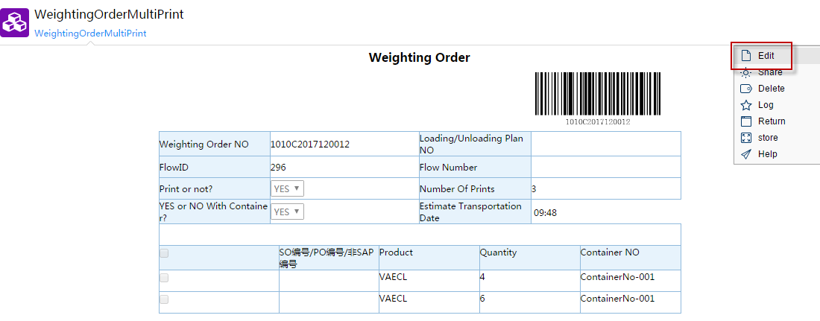

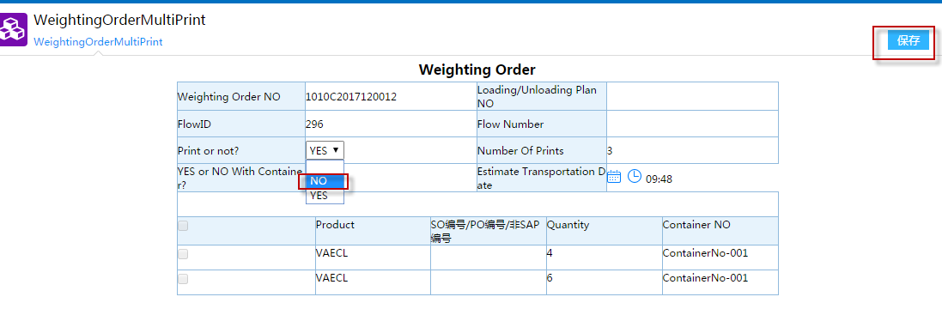

#### Reprint Weighting Order again

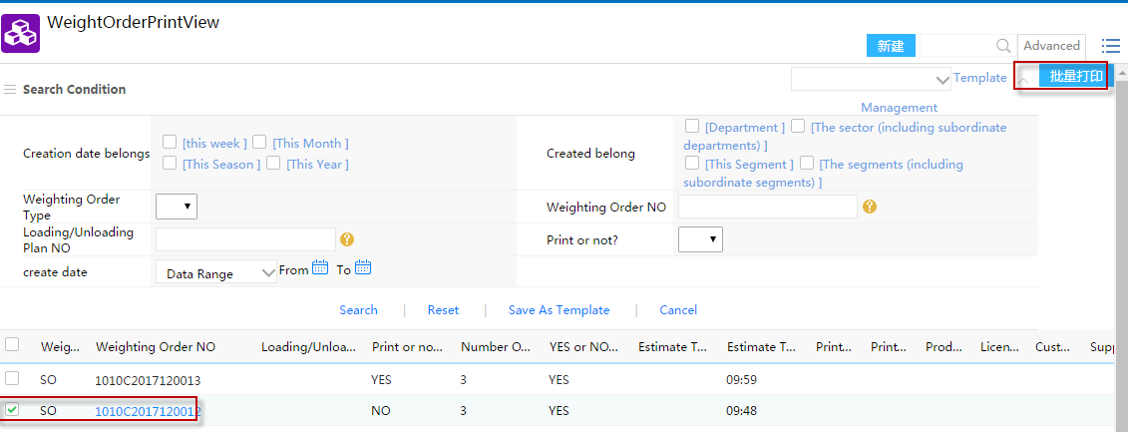

### Incoming Weighting

门卫操作: Weighting

### 仓库装货

系统外

### Ongoing Weighting

门卫操作

### Print Deliver Order

#### Open SO Loading/Unloading Plan Form









#### Click “CLICK TO PRINT”

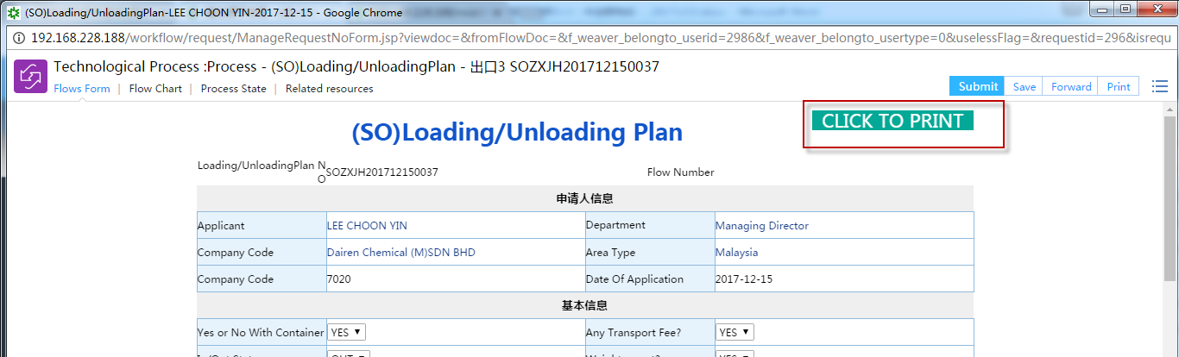

#### Confirm print

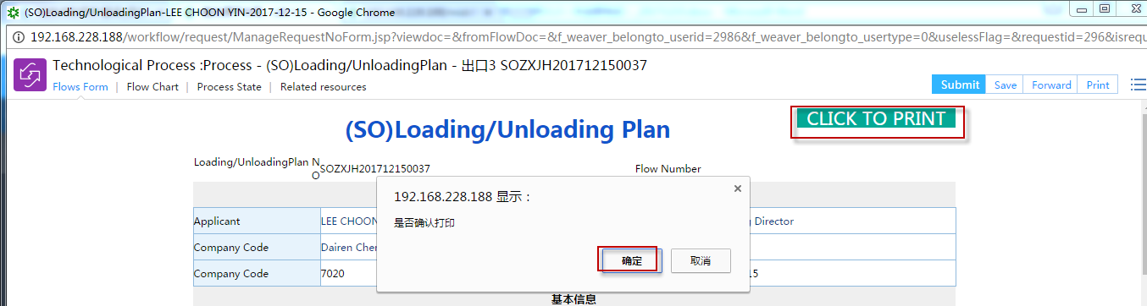

#### Print View and print

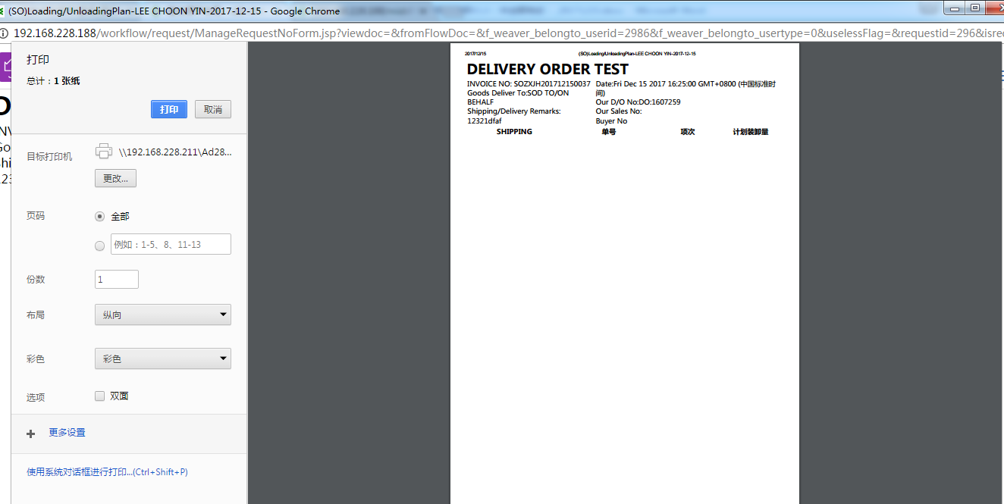

## SO销售出货(无柜/无ISOTANK)

### 数据同步Syc ShippingAdvice&SAPDO

同上

### SO装卸计划Loading/UnloadingPlan

#### 未完待续……

### 理货清单StuffingOrderList

#### 未完待续……

### Print Weighting Order

同上

### Incoming Weighting

门卫操作: Weighting

### 仓库装货

系统外

### Ongoing Weighting

门卫操作

### Print Deliver Order

同上